Data structure lecture

Tree:hierarichal structure

→It cosists of nodes →parents vs.childrens

→siblings →ancestorsvs.descentants

Binary tree

types of tree: 1.pre-order 2.in-order 3.post-order

post-order

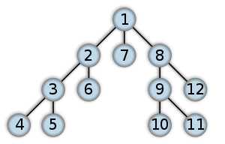BFS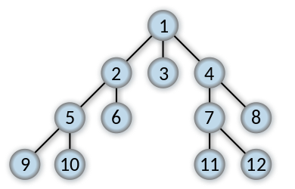DFS

TREE:special type from data type called graph

.GRAPH

-connected vs.notconnected

-directed or un directed

-weighted vs.notweighted

-cyclic vs.acyclic

-dens vs.sparse

→How to implement graph

1-by 2d array→matrix array

Un directed and weighted but the value of edgeson matrix

2-if it's directed and weighted graph by using adjacency matrix

3-if it's sparse graph →have no edges

By adjacency matrix

Code→int main(void){

Int g[10][10];

Int g[0][1]=5;

Int g[0][2]=2;

Int g[1][0]=5;

Int g[2][0]=2;

Int g[5][6]=3;

Int g[6][5]=3;}

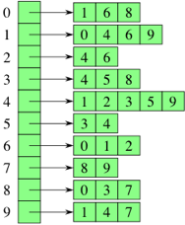By adjancency list

code→int main(void)

struct node{ int key; struct node\*next;}

g[i]=null ptr; g1 key=1

int weight; struct node g1; g1 weight=5;

g[0]=g1;→struct node g2;

g2=key=2; g2.weight=2; g1.next=g2;}

→cirteria:

Perform 1-time

2-size

